Technical Datasheet Input / Output Modules with Modbus RTU Protocol with RS485 Interface

8DDAPM Module: -

The RS485 IO module is a compact, robust, and low-power device designed for reliable communication over distances up to 700 meters without a repeater, depending on the signal strength of the Modbus master. It features 8 digital inputs, 8 digital outputs, 8 analog inputs (10-bit resolution, supporting 0–20 mA and 0–10 V), and 8 RTD (PT1000) channels, making it ideal for versatile industrial applications. Housed in a DIN rail-mountable enclosure, the module includes exposed connectors for easy wiring and LED indicators for real-time I/O status monitoring. Configuration of slave ID and baud rate is done via internal DIP switches. To enhance system protection, the module is equipped with resettable fuses guarding against reverse polarity on both power and RS485 communicatio
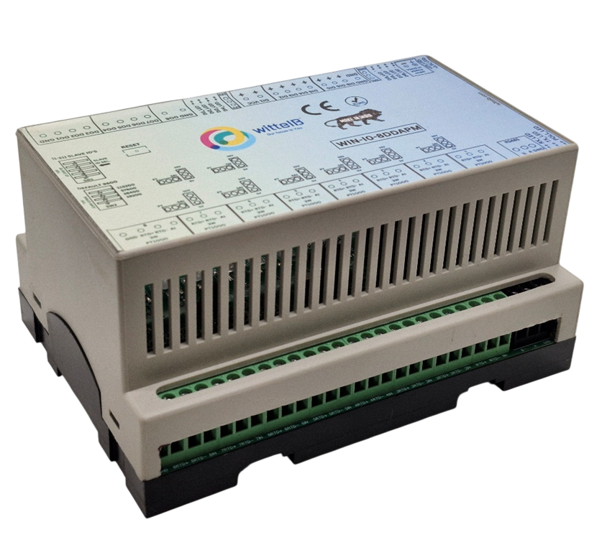
Specifications
General –
I/O Connectors 2 Pin 5.08 mm pitch pluggable screw terminals.
Dimensions 155 mm L x 110 mm B x 75 mm H
Power Input Power – 12 - 24 VDC
Typical – 12V DC @ 120mA
Operating Temperature 0 – 60° C (32 ~ 140°F)
Storage Temperature -20 - 70° C (-4 ~ 158°F)
Storage Humidity 5 ~ 95 % RH, non – Condensing
Certifications 

DI Inputs –
Channels 8
Sense Voltage 3.3 – 30 VDC
Sense Logic Logic ‘0’ = <1 VDC, Logic ‘1’ = >3.3 VDC
Isolation Optically isolated
Response Time 2 msec, Max 6 msec

Digital Output
Channels 8
Output Type P-Channel MOSFET
Channel Voltage 12 VDC/24 VDC
Channel Current 20A
Channel Power 240 W (max)
Operating Time 2.8ns.
Turn Off delay Time 33.5ns.
Operating Temperature -55℃~+150

AI Inputs –
Channels 8
Input Signal 4 – 20 mA / 0 – 10VDC
Accuracy ± 2% Full scale
Input Resolution 10 bits
Isolation Optically Isolated
External Loop Voltage + 12 VDC min
AI input impedance 120Ω

AI Inputs –

Channels 8– PT1000 – (jumper selectable) three wire
Accuracy Total Accuracy over All Operating Conditions: 0.5NC
(0.05% of Full Scale) max.

Input Resolution 15-Bit ADC Resolution.
Isolation Optically Isolated.

Additional Features: -

All inputs and communication ports isolated
Input power reverse polarity safety
ESD Safety IEC 61000-4-2, ± 30KV contact, ± 30KV air
EFT IEC 61000-4-4, 50A (5/50ms)
750V isolation.
CRC Error check.
No configuration needed on the IO board

Configuration Settings: -

Communication Speed 9600 – 115200 (DIP SW selectable)
Data Bits 8
Parity None
Stop bit 1
CRC Yes
Slave ID Configurable with DIP Switch
Function code DO 0x05 and 0x0F (5 Single coil & 15 multiple coil)
DO Register Address 0,1,2,3,4,5,6,7.
Function code DI 0x02 Read discrete Input
DI Register Address 8, 9,10,11,12,13,14,15.
Function Code AI 0x03 Read Holding Registers
AI Register Address 10 Bit – 1, 2, 3, 4, 5, 6, 7, 8.
RTD Register Address 9, 10, 11, 12, 13,14,15,16.

ID | Function  Description | Register  Description | Modbus Function Code | Protocol | Data  Type
1 | DO 1 | 00001 | 0X05,0X0F | RS485 | 1 Bit Boolean
2 | DO 2 | 00002 | 0X05,0X0F | RS485 | 1 Bit Boolean
3 | DO 3 | 00003 | 0X05,0X0F | RS485 | 1 Bit Boolean
4 | DO 4 | 00004 | 0X05,0X0F | RS485 | 1 Bit Boolean
5 | DO 5 | 00005 | 0X05,0X0F | RS485 | 1 Bit Boolean
6 | DO 6 | 00006 | 0X05,0X0F | RS485 | 1 Bit Boolean
7 | DO 7 | 00007 | 0X05,0X0F | RS485 | 1 Bit Boolean
8 | DO 8 | 00008 | 0X05,0X0F | RS485 | 1 Bit Boolean
9 | DI 1(With & Without Potential) | 10009 | 0X02 | RS485 | 1 Bit Boolean
10 | DI 2(With & Without Potential) | 10010 | 0X02 | RS485 | 1 Bit Boolean
11 | DI 3(With & Without Potential) | 10011 | 0X02 | RS485 | 1 Bit Boolean
12 | DI 4(With & Without Potential) | 10012 | 0X02 | RS485 | 1 Bit Boolean
13 | DI 5(With & Without Potential) | 10013 | 0X02 | RS485 | 1 Bit Boolean
14 | DI 6(With & Without Potential) | 10014 | 0X02 | RS485 | 1 Bit Boolean
15 | DI 7(With & Without Potential) | 10015 | 0X02 | RS485 | 1 Bit Boolean
16 | DI 8(With & Without Potential) | 10016 | 0X02 | RS485 | 1 Bit Boolean
17 | AI 1 | 40002 | 0X03 | RS485 | 16 Bit Unsigned int
18 | AI 2 | 40003 | 0X03 | RS485 | 16 Bit Unsigned int
19 | AI 3 | 40004 | 0X03 | RS485 | 16 Bit Unsigned int
20 | AI 4 | 40005 | 0X03 | RS485 | 16 Bit Unsigned int
21 | AI 5 | 40006 | 0X03 | RS485 | 16 Bit Unsigned int
22 | AI 6 | 40007 | 0X03 | RS485 | 16 Bit Unsigned int
23 | AI 7 | 40008 | 0X03 | RS485 | 16 Bit Unsigned int
24 | AI 8 | 40009 | 0X03 | RS485 | 16 Bit Unsigned int
25 | RTD1 1000 | 40010 | 0X03 | RS485 | 16 Bit Unsigned int
26 | RTD2 1000 | 40011 | 0X03 | RS485 | 16 Bit Unsigned int
27 | RTD3 1000 | 40012 | 0X03 | RS485 | 16 Bit Unsigned int
28 | RTD4 1000 | 40013 | 0X03 | RS485 | 16 Bit Unsigned int
29 | RTD5 1000 | 40014 | 0X03 | RS485 | 16 Bit Unsigned int
30 | RTD6 1000 | 40015 | 0X03 | RS485 | 16 Bit Unsigned int
31 | RTD7 1000 | 40016 | 0X03 | RS485 | 16 Bit Unsigned int
32 | RTD8 1000 | 40017 | 0X03 | RS485 | 16 Bit Unsigned int

Note: -
For MODBUS communications, a shielded and twisted pair cable is used. One example of such cable is Belden 3105A.
Recommended Cable Electrical Characteristics: -
22 AWG Cable Shielded and twisted pair should be used.
Tinned Copper Recommended
Nominal Conductor DCR 14.7 ohm / 1000 ft
Nominal Capacitance 11 pf / feet (conductor to conductor)
High Frequency Non-Insertion Loss 0.5db / 100ft

Connection Instruction FOR WIN - IO – 8DDAPM

H2
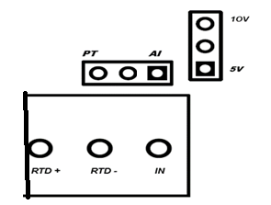
H1

Note:
      - Identify the AI/PT1000 wiring, configuration, or specification
      - For AI there are 2 Jumpers Eg. Jumper “H1” & “H2” are for Selecting the Input Voltage Detection. + & - Terminal are used for all AI INPUT
The system supports monitoring of both Analog Input (AI) and RTD (PT1000) sensor data.
      - Selection between AI and RTD input modes is achieved by configuring the appropriate jumper settings. Refer to the provided diagram for correct jumper positions and wiring connections.
      - Ensure that only one mode is selected at a time to prevent signal conflict or inaccurate readings.
      - H1 is for selection of analog input and RTD(PT1000)
      - H2 is for voltage selection between 5V and 10V.

DI

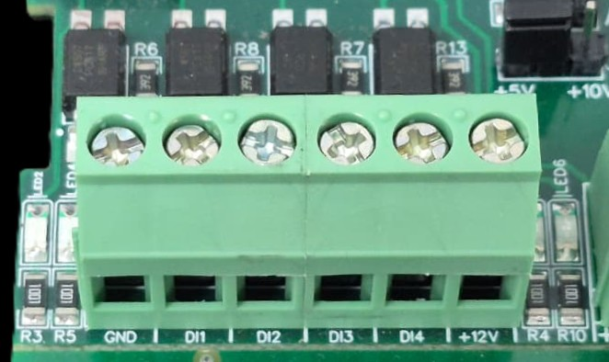
I/p device
I/p device
I/p device
I/p device

- Operation: The module provides four isolated input channels (DI1–DI4) for sensing external signals or dry contacts. These inputs are opto-isolated for circuit protection.
- Terminal Layout:
  - GND: Common Ground reference.
  - DI1 – DI4: Individual Digital Input channels.
  - +12V: Internal reference voltage for sourcing "Dry Contact" switches.
- Wiring Options:
  - Dry Contact: Connect a switch between the +12V terminal and any DI pin.
  - External Voltage: Connect the external signal to a DI pin and the external ground to the GND terminal.
- Voltage Rating: The input circuitry is rated for a maximum of 80VDC. Ensure external signals do not exceed this limit to prevent damage to the isolation ICs.

BAUD RATE DESCRIPTION

LSB
MSB
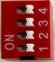

- For Baud rate Selection, DIP SW is used as per the diagram.
- Pulling up the switch will make Baud rate active.
- If no selection is made 9600 will be default Baud rate.
- When u change the Baud rate in the Module power ‘ON’ condition,
pls press the reset button to get Change to affect.
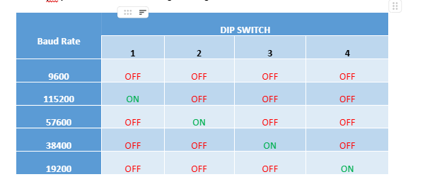

SLAVE ID DESCRIPTION

MSB
LSB
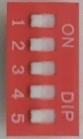

For Slave ID Selection SW is used to Set The SLAVE ID .
For Slave ID DIP Switch LSB is “1” follow through “5” is MSB.
Slave ID Confirmed through below Device ID table .
IF Eg. Slave ID 1 is Needed to be selected Switch number 1 should pulled up other three should be selected down side. So”0 0 0 0 1” will be selected as Slave ID 1.

Slave ID Configuration
The slave ID can be configured as per user preference using a 5-bit DIP switch setting. The binary value set by the switches corresponds to a specific decimal slave ID.
Binary (DIP Switch) | Decimal Slave ID
00001 | 1
10000 | 16
11111 | 31
Note:
- Bit position and value mapping may vary based on hardware implementation (e.g., LSB ↔ MSB). Refer to the device’s DIP switch bit order specification when setting the ID.
- DIP switches SW1 to SW5 are provided for user configuration. These switches can be set as per the application requirements to control functions such as slave address selection, mode settings, or other device parameters.
- The device supports configurable slave addresses within the range of 1 to 31, which can be set according to application requirements.
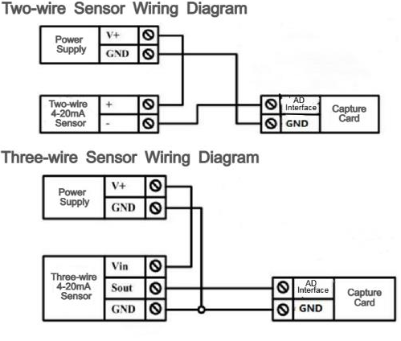
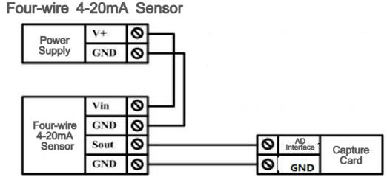

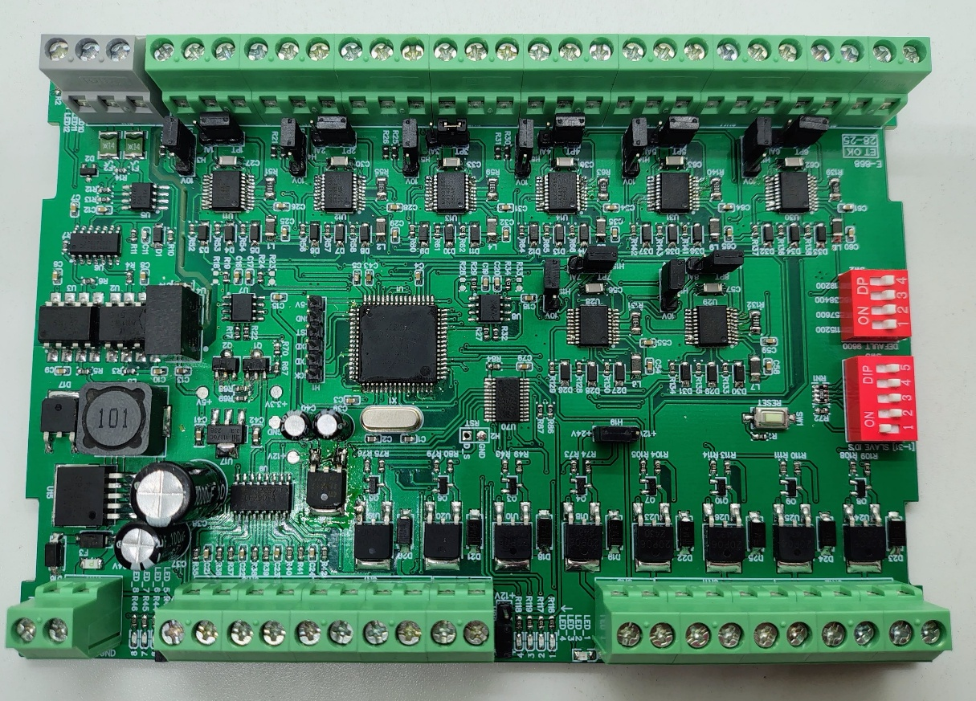
Common
GND
1 2 3 4 5 6 7 8
AI / PT 1000 Channel

Modbus RS485
5V/10V
Jumper
AI/PT
Jumper
SLAVE ID

BAUD RATE

DI8 DI7 DI6 DI5 DI4 DI3 DI2 DI1
DI Channel
DO8 D07 DO6 DO5 DO4 DO3 DO2 DO1
DO Channel
Input 12-24 VDC
+12/24V Reference Voltage

Contact us: -
Augmatic Technologies Pvt. Ltd.,
Plot no 6, Shah Industrial Estate II,
Kotambi,
Vadodara – 391510.
Email – Sales@wittelb.com
Support: support@wittelb.raiseaticket.com / +91 94038 92805

